




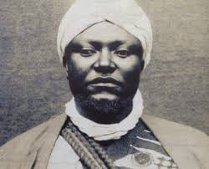
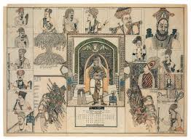
King Ibrahim Mbouombouo Njoya of Bamum
1860 – c. 1933

Innovations:
-the Bamum script
-a hand-powered mill for grinding corn and other cereals.
-The Bamum School
-He was a cartoonist; and used cartoons to tell the story of his Kingdom
He was an architect

